UNSUPERVISED CLUSTERING
OF STUDENT STRESS PATTERNS
Project Report: Student Stress Factors Dataset
Techniques: K-Means, Agglomerative Hierarchical Clustering, DBSCAN, PCA, SNE and t-SNE
Tools: Python, pandas, NumPy, scikit-learn, SciPy, seaborn and matplotlib

1. Executive Summary
This project applies unsupervised learning to a dataset of 1,100 student records. Twenty recorded variables covering psychological, physiological, environmental, academic and social factors were used to explore similarities between student profiles. The supplied stress_level column was kept outside preprocessing, dimensionality reduction and model fitting. It was used only after clustering for a post-clustering comparison.
Three clustering algorithms were implemented and compared: K-Means, Agglomerative Hierarchical Clustering and DBSCAN. PCA, t-SNE and an implementation of original SNE were used to examine lower-dimensional representations. The analysis also includes cluster-size summaries, internal evaluation measures, pairwise agreement, post-clustering validation and a repeated-run stability check for K-Means.
K-Means selected five clusters and assigned all 1,100 records. Its Silhouette Score was 0.4489. Agglomerative Clustering also produced five clusters, with a Silhouette Score of 0.3667. DBSCAN identified four density-based clusters and marked 209 records (19%) as noise. Its Silhouette Score was 0.4832 on the 891 records assigned to clusters; this value is based on a subset and should not be compared directly with scores calculated on all records.
Among the full-coverage methods, K-Means had the highest Silhouette Score and Calinski-Harabasz Score, while Agglomerative Clustering had the lower Davies-Bouldin Index. On the DBSCAN non-noise subset, K-Means achieved a Silhouette Score of 0.5706. K-Means was also consistent across repeated runs, with a mean pairwise ARI of 0.9383. PCA required 16 components to retain at least 95% of the variance; the first two components explained 65.54%. The SNE optimizer converged on a reproducible sample of 800 records.

Key findings
- The selected K-Means solution contains five clusters, with cluster sizes ranging from 95 to 308 records.
- DBSCAN assigned 891 records to four clusters and marked 209 records (19%) as noise.
- DBSCAN noise was concentrated in specific groups identified by K-Means and Agglomerative Clustering.
- K-Means and Agglomerative Clustering showed a pairwise ARI of 0.8337 on the full dataset; Agglomerative and DBSCAN had an ARI of 0.9819.
- The corrected SNE optimization converged after 106 iterations, with all 800 coordinates finite.

2. Objective and Scope
The objective of the project is to identify groups of students with similar profiles across the available stress-related factors without using the existing stress_level label to form those groups. The work focuses on clustering, dimensionality reduction, evaluation and interpretation of the resulting partitions.
The project covers the following tasks:
- Inspect the dataset and review feature ranges, distributions, missing values and relationships.
- Prepare the 20 predictor variables for distance-based analysis.
- Select a suitable K value for K-Means and compare three clustering approaches.
- Tune DBSCAN while considering both cluster quality and the proportion of records classified as noise.
- Use PCA, t-SNE and SNE to examine lower-dimensional representations of the observations.
- Compare algorithm assignments and perform post-clustering validation against the held-out stress_level label.

3. Dataset
The analysis uses StressLevelDataset.csv, containing 1,100 student records and 21 columns. The file has 20 predictor variables and one stress_level column. All columns were stored as int64 in the inspected CSV, and the initial inspection reported no missing values.
The dataset is associated with a research article published in September 2024. The CSV file itself does not establish the original survey collection date; therefore, the publication date is not treated as the collection year.
Property | Value
Dataset file | StressLevelDataset.csv
Records | 1,100
Columns | 21
Predictor variables | 20
Held-out label | stress_level
Stored data type | Integer-coded values (int64)
Missing values in inspected file | None reported
Associated publication | September 2024

3.1 Features used for clustering
All 20 predictor columns were retained as inputs in the baseline experiments. They are grouped into five subject areas in the related dataset description.
Factor group | Features
Psychological | anxiety_level; self_esteem; mental_health_history; depression
Physiological | headache; blood_pressure; sleep_quality; breathing_problem
Environmental | noise_level; living_conditions; safety; basic_needs
Academic | academic_performance; study_load; teacher_student_relationship; future_career_concerns
Social | social_support; peer_pressure; extracurricular_activities; bullying

3.2 Treatment of the target column
The stress_level column contains three encoded values (0, 1 and 2). It was separated from the predictors before imputation, scaling, PCA, SNE, t-SNE and clustering. It was used only after model fitting for cross-tabulation and external comparison with Adjusted Rand Index (ARI) and Normalized Mutual Information (NMI). Cluster IDs are algorithm-specific identifiers and are not assumed to represent low, medium or high stress.

4. Methodology

4.1 Exploratory data analysis
The dataset was examined using a preview, data types, descriptive statistics, missing-value counts and duplicate-row checks. Histograms were produced for the predictor variables. A Spearman correlation heatmap was used to examine relationships between the ordered score variables. Boxplots were used to review feature ranges and possible extreme observations. No missing values were found in the inspected predictor columns.
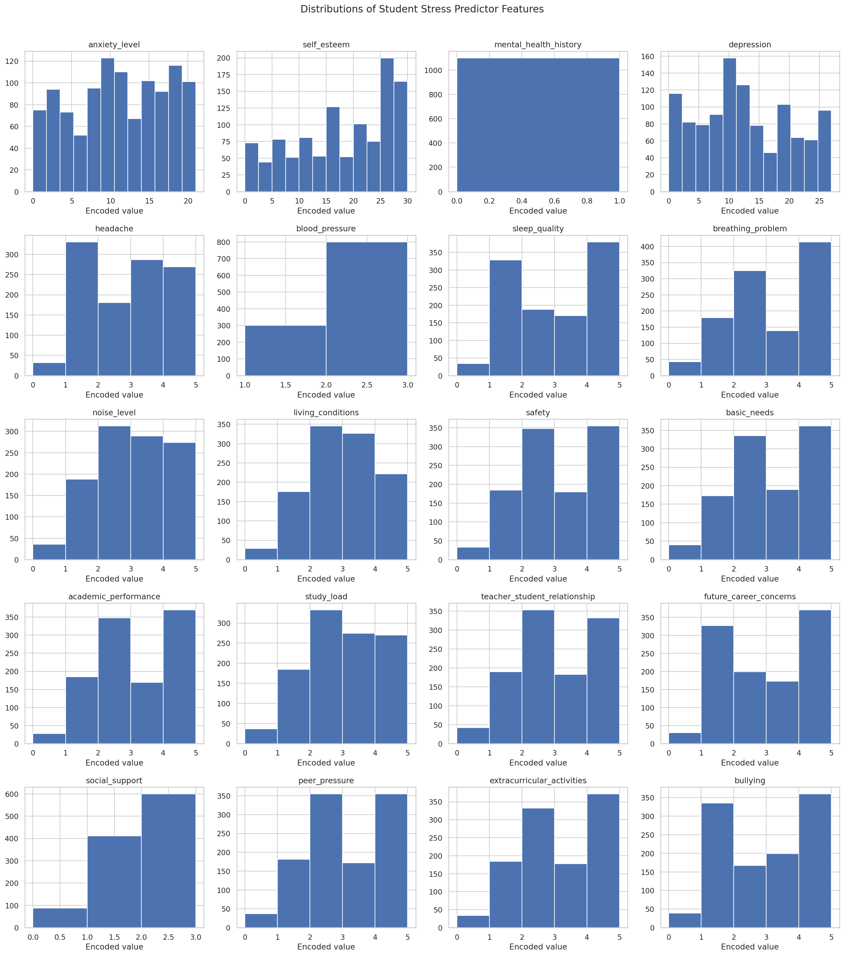
Figure 1. Distributions of the 20 predictor features.
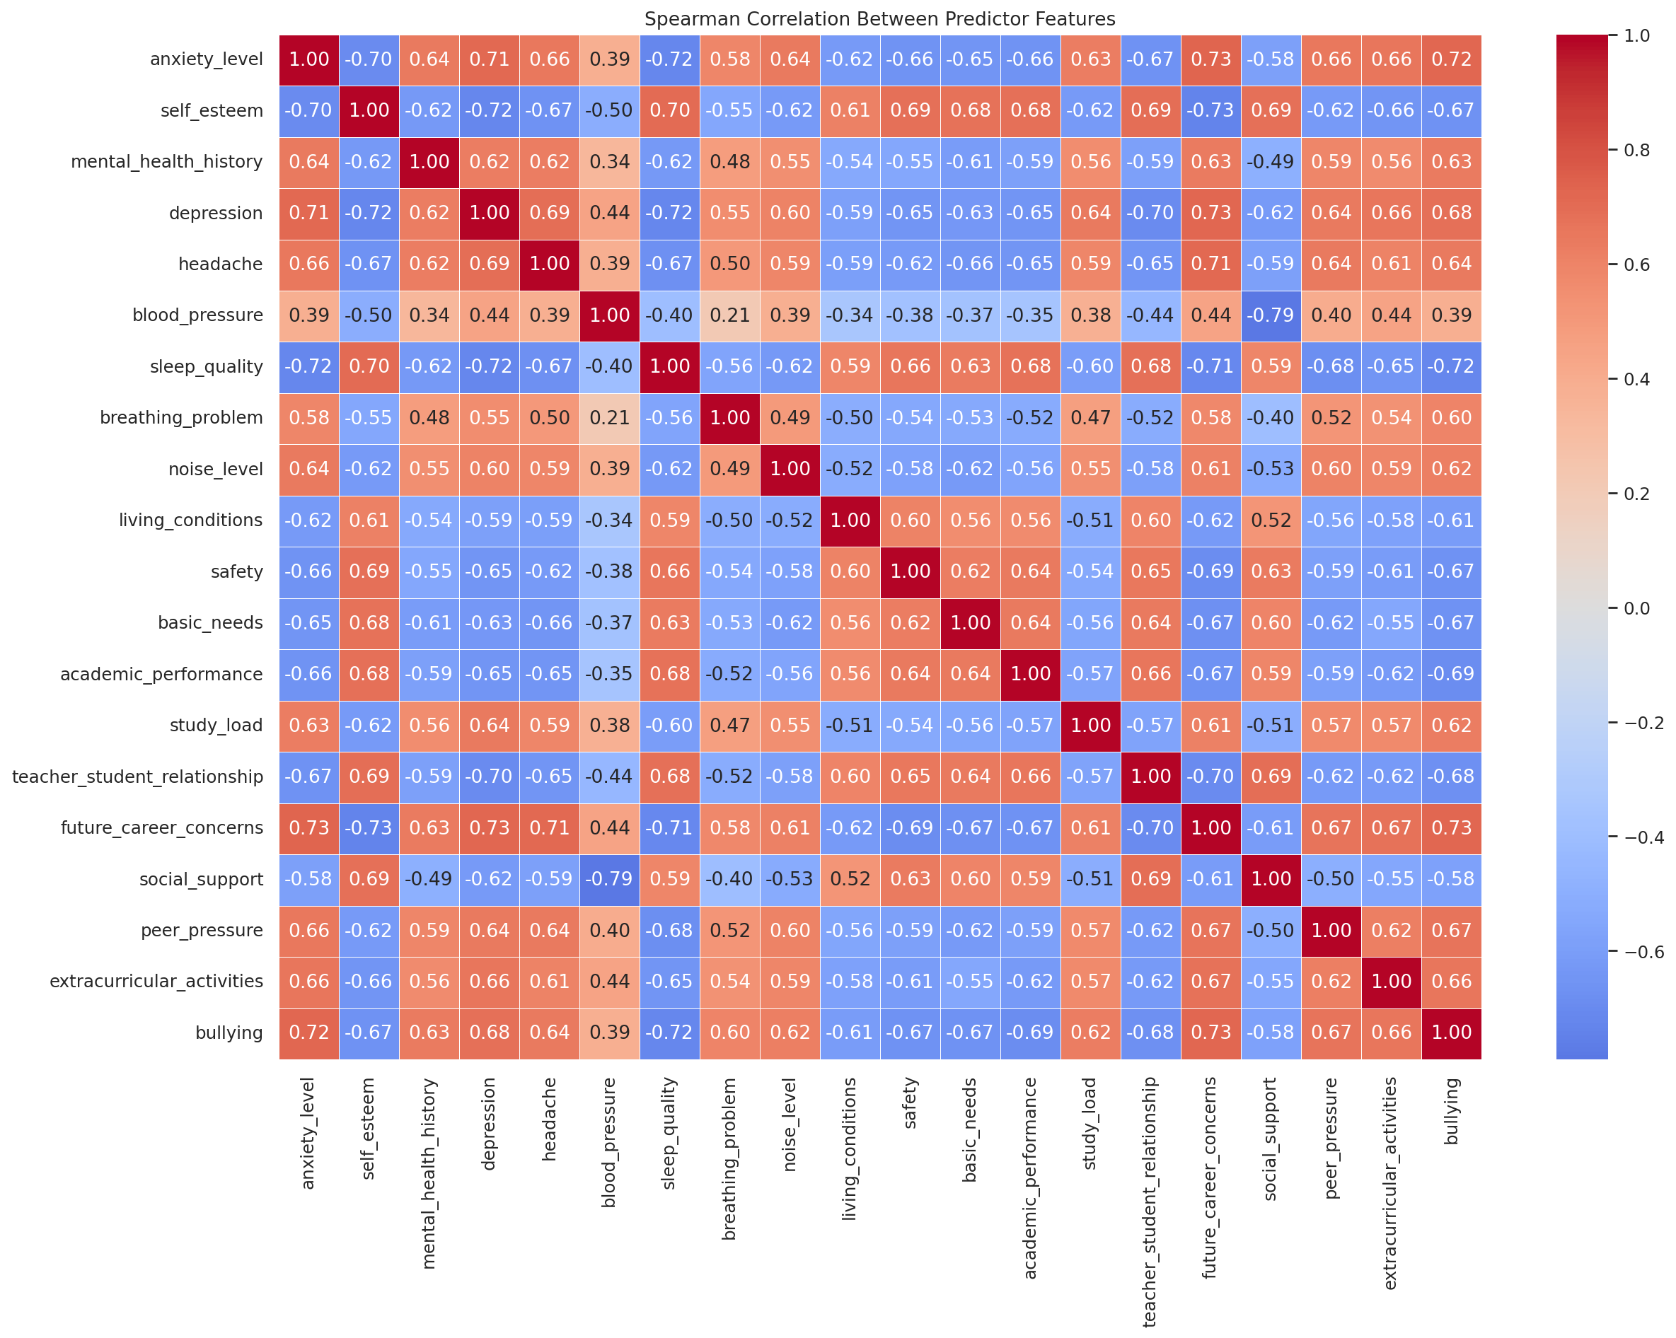
Figure 2. Spearman correlation matrix for the predictor variables.

4.2 Preprocessing
The stress_level column was removed from the predictor matrix. Predictor columns were converted to numeric values, median imputation was included for robustness, and StandardScaler was applied so that features with larger numeric ranges did not dominate distance calculations solely because of scale. The baseline analysis retained the numeric ordering of the integer-coded variables. This is a modelling assumption; alternative encoding or feature-weighting choices may change the clustering results.

4.3 Selecting the K-Means cluster count
K-Means was evaluated for K values from 2 to 10. Inertia was recorded for the Elbow Method and the Silhouette Score was calculated for each candidate solution. The highest observed Silhouette Score occurred at K = 5, which was used for the final K-Means and Agglomerative models.
K | Inertia | Silhouette Score
2 | 12,737.60 | 0.3974
3 | 8,768.21 | 0.4170
4 | 7,581.83 | 0.4430
5 | 7,221.64 | 0.4489
6 | 6,919.62 | 0.3730
7 | 6,688.41 | 0.3770
8 | 6,531.41 | 0.3798
9 | 6,443.30 | 0.2506
10 | 6,353.81 | 0.2522

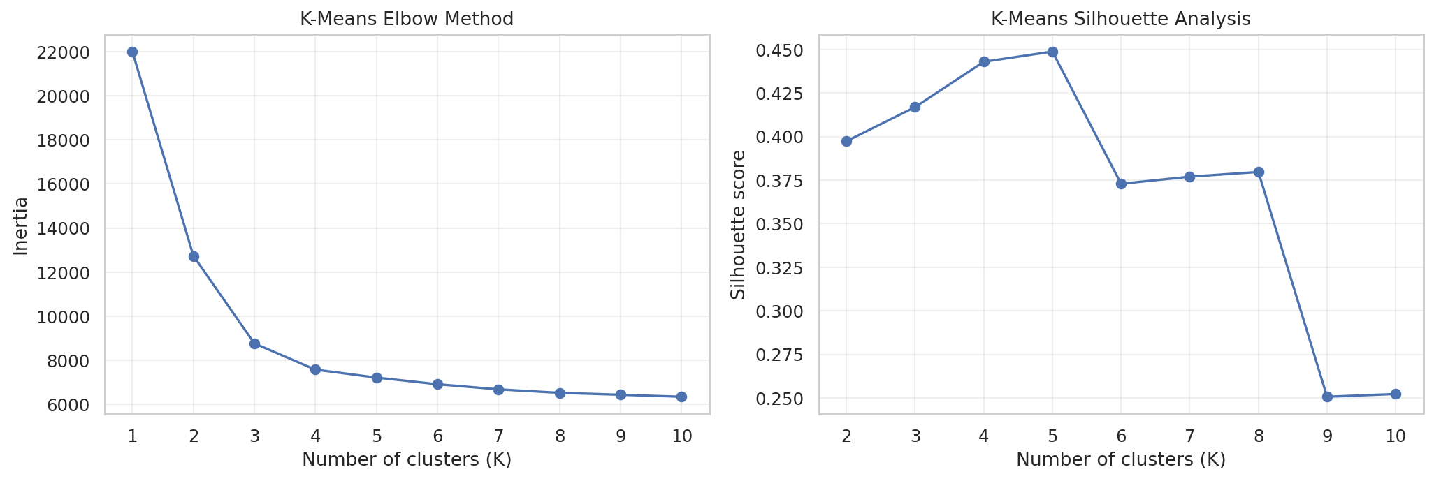
Figure 3. K-Means inertia and Silhouette Score across candidate cluster counts.

4.4 Clustering algorithms
Algorithm | Configuration used
K-Means | K = 5; random_state = 42; 20 initialisations (n_init = 20).
Agglomerative Hierarchical Clustering | 5 clusters; Ward linkage; Euclidean geometry.
DBSCAN | eps = 1.809; min_samples = 15; 4 non-noise clusters.

4.5 DBSCAN parameter selection
DBSCAN was tuned using min_samples values of 5, 10 and 15. Candidate eps values were generated from quantiles of nearest-neighbour distances. The selection rule required at least two clusters and at least 50% coverage. Among the configurations meeting those conditions, the one with the highest Silhouette Score was selected. The chosen setting was eps = 1.809 and min_samples = 15.
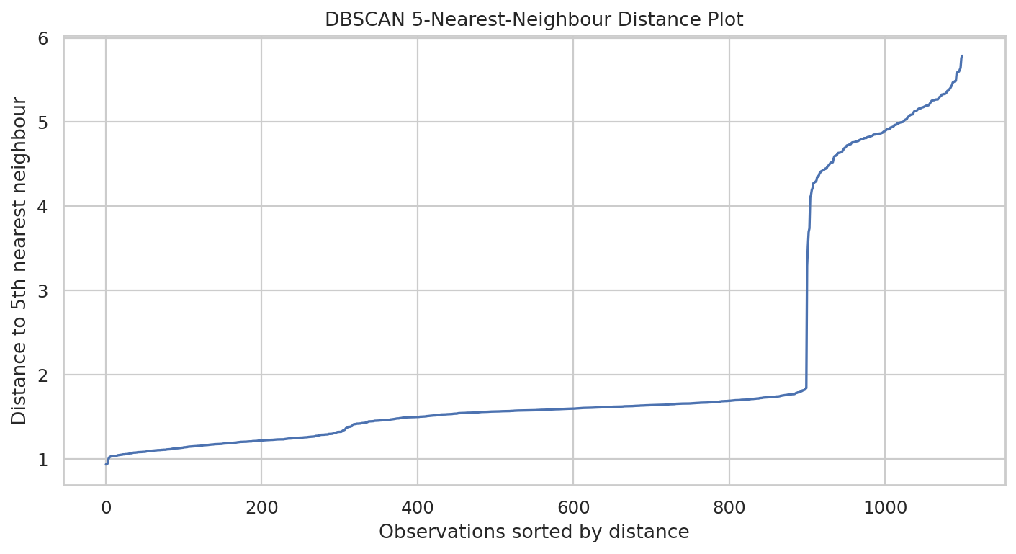
Figure 4. Distance to the fifth nearest neighbour, used to inspect DBSCAN eps values.

4.6 Evaluation measures
Measure | Interpretation
Silhouette Score | Higher values indicate better cohesion within clusters relative to separation from other clusters.
Davies-Bouldin Index | Lower values indicate lower similarity between each cluster and its closest neighbouring cluster.
Calinski-Harabasz Score | Higher values indicate greater between-cluster dispersion relative to within-cluster dispersion.
Adjusted Rand Index (ARI) | Measures agreement between two partitions, correcting for chance.
Normalized Mutual Information (NMI) | Measures shared information between two sets of labels.

5. Results

5.1 Full-dataset clustering comparison
K-Means and Agglomerative Clustering were evaluated on all 1,100 observations. DBSCAN identified 891 non-noise observations; the remaining 209 observations were excluded from its internal metric calculations.
Algorithm | Clusters | Coverage % | Noise % | Silhouette | Davies-Bouldin | Calinski-Harabasz
K-Means | 5 | 100.0 | 0.0 | 0.4489 | 2.3097 | 560.20
Agglomerative | 5 | 100.0 | 0.0 | 0.3667 | 1.7272 | 549.26
DBSCAN | 4 | 81.0 | 19.0 | 0.4832 | 1.1294 | 1797.00

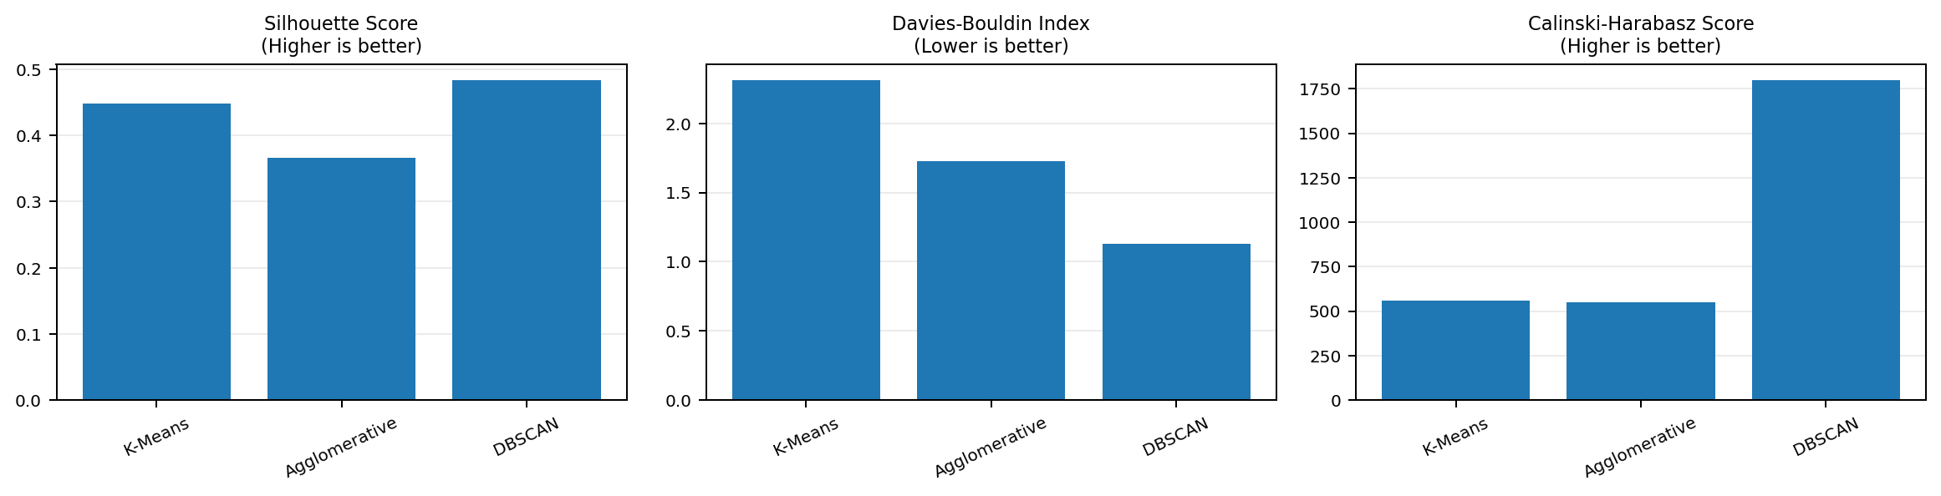
Figure 5. Internal clustering metrics for the three algorithms. DBSCAN metrics use non-noise observations.
Among the full-coverage methods, K-Means had the highest Silhouette Score (0.4489) and Calinski-Harabasz Score (560.20). Agglomerative Clustering had the lower Davies-Bouldin Index (1.7272). DBSCAN had the highest Silhouette Score and lowest Davies-Bouldin Index in the table, but these values were calculated on 81% of the observations. They should be interpreted together with DBSCAN coverage and the subset comparison in Section 5.2.

5.2 Comparison on the DBSCAN non-noise subset
To compare the methods on the same observations, all three algorithms were evaluated again on the 891 records assigned to clusters by DBSCAN. K-Means formed three represented clusters on this subset, while Agglomerative Clustering and DBSCAN each formed four.
Algorithm | Clusters on subset | Silhouette | Davies-Bouldin | Calinski-Harabasz
K-Means | 3 | 0.5706 | 0.6878 | 2332.59
Agglomerative | 4 | 0.4832 | 1.1294 | 1797.00
DBSCAN | 4 | 0.4832 | 1.1294 | 1797.00

5.3 Distribution of DBSCAN noise
DBSCAN assigned 891 records (81%) to four density-based clusters and classified 209 records (19%) as noise. The noise observations were concentrated in particular groups produced by the other algorithms.
Reference partition | Clusters containing most noise | Noise records | Share of all noise
K-Means | Clusters 2 and 4 | 192 | 91.9%
Agglomerative | Cluster 0 | 200 | 95.7%

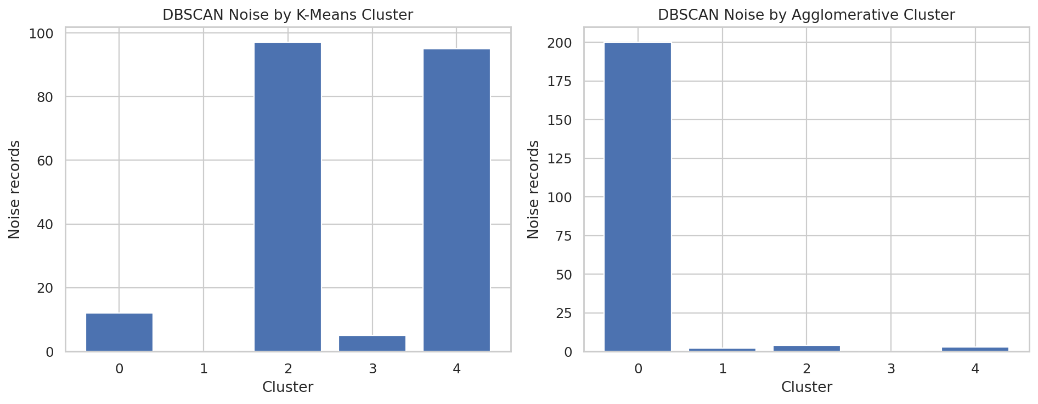
Figure 8. DBSCAN noise observations across the K-Means and Agglomerative partitions.
For K-Means, all 97 observations in cluster 2 and all 95 observations in cluster 4 were labelled as DBSCAN noise. For Agglomerative Clustering, all 200 observations in cluster 0 were labelled as noise. In DBSCAN, noise means that an observation did not meet the selected density requirements; it does not mean that the record is erroneous or that the student has an abnormal stress profile.

5.4 Pairwise agreement between algorithms
Pairwise Adjusted Rand Index was used to compare the assignments produced by each pair of algorithms. An ARI of 1.0 indicates identical partitions, even when the numerical cluster IDs differ.
Algorithm 1 | Algorithm 2 | Full dataset ARI | DBSCAN non-noise ARI
K-Means | Agglomerative | 0.8337 | 0.8712
K-Means | DBSCAN | 0.8165 | 0.8712
Agglomerative | DBSCAN | 0.9819 | 1.0000

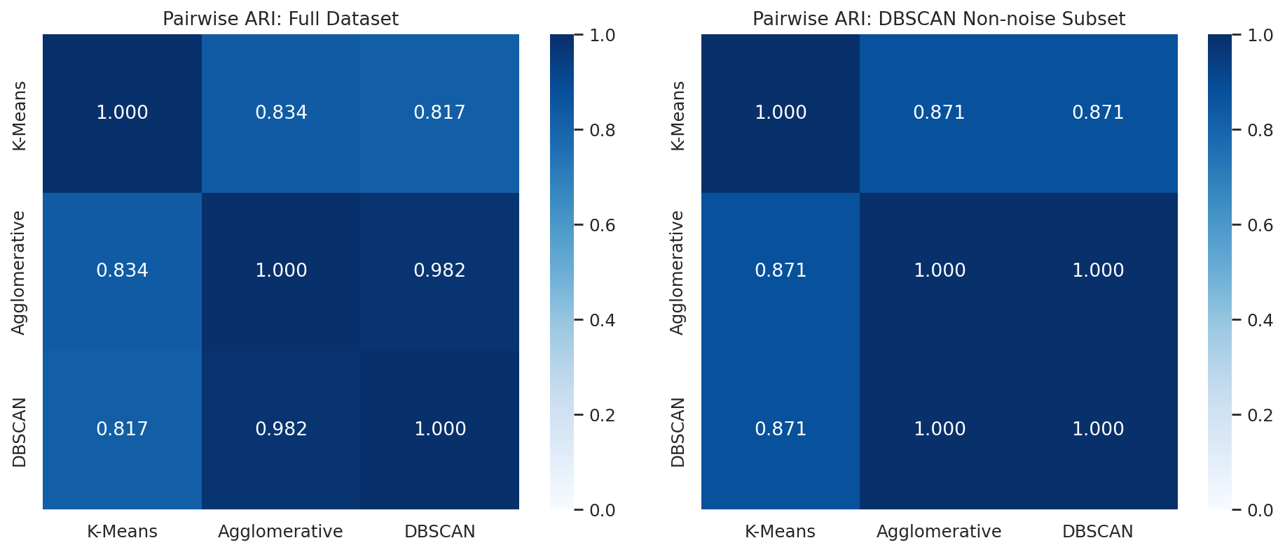
Figure 9. Pairwise ARI for the full dataset and DBSCAN non-noise subset.
K-Means and Agglomerative Clustering had an ARI of 0.8337 on the full dataset. K-Means and DBSCAN had an ARI of 0.8165. Agglomerative Clustering and DBSCAN showed the strongest full-dataset agreement, with an ARI of 0.9819. On the DBSCAN non-noise subset, Agglomerative Clustering and DBSCAN had identical assignments (ARI = 1.0000).

5.5 K-Means cluster sizes and profiles
Cluster (records, %) | Anxiety | Self-esteem | Depression | Sleep quality | Academic performance | Career concerns
0 (308, 28.0%) | 18.0 | 7.8 | 21.4 | 1.0 | 1.5 | 4.5
1 (300, 27.3%) | 4.2 | 27.4 | 4.1 | 4.5 | 4.5 | 1.0
2 (97, 8.8%) | 9.5 | 16.3 | 14.6 | 2.8 | 2.5 | 2.4
3 (300, 27.3%) | 11.4 | 20.0 | 11.6 | 2.5 | 2.5 | 2.5
4 (95, 8.6%) | 10.8 | 14.1 | 11.6 | 2.7 | 2.7 | 2.8

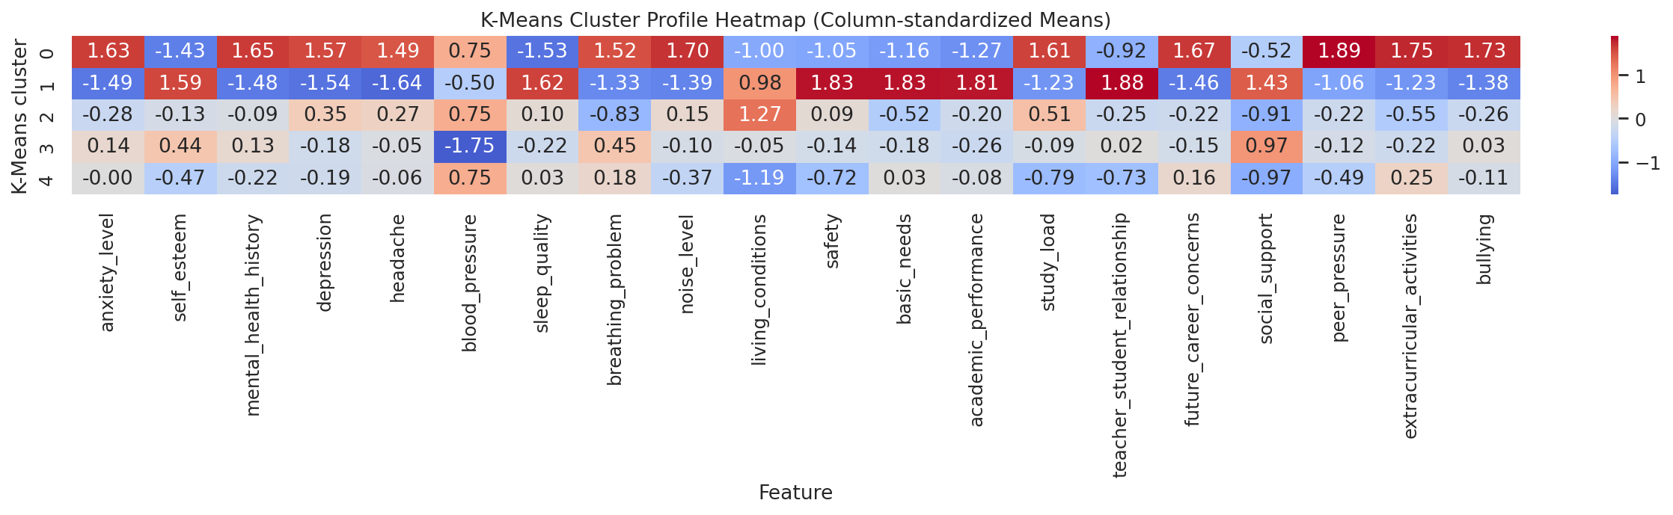
Figure 10. K-Means cluster means, standardized by feature for display.
The cluster profiles show differences across the recorded score variables. For example, K-Means cluster 0 has higher mean anxiety and depression scores and lower mean self-esteem and sleep-quality scores than cluster 1. Cluster 1 shows the opposite pattern on these selected variables. The remaining clusters have intermediate or mixed averages. The cluster IDs are identifiers only; descriptive stress labels should not be assigned without confirming the original score definitions.

5.6 Post-clustering comparison with stress_level
After clustering, the model assignments were compared with the held-out stress_level values. This column was not used during preprocessing, dimensionality reduction or model fitting. The measures below describe agreement with the supplied label; they do not show that the clustering methods predict or diagnose stress.
Algorithm | Adjusted Rand Index | Normalized Mutual Information
K-Means | 0.7166 | 0.6792
Agglomerative | 0.6096 | 0.6763
DBSCAN | 0.5990 | 0.6692

K-Means had the highest post-clustering ARI (0.7166), while its NMI was 0.6792. Agglomerative Clustering recorded an ARI of 0.6096 and NMI of 0.6763. DBSCAN recorded an ARI of 0.5990 and NMI of 0.6692. The encoded meanings of stress_level values 0, 1 and 2 should be verified before assigning descriptive names to them.

5.7 K-Means stability
K-Means was rerun using ten random seeds. Pairwise ARI was calculated between the assignments from these runs. The mean pairwise ARI was 0.9383, indicating that the five-cluster solution was consistent across the tested random initialisations and seeds.

5.8 Principal Component Analysis
PCA was fitted to the standardized 20-feature matrix. Sixteen principal components were required to retain at least 95% of the total variance. The first two components explained 65.54% of the variance, so the two-dimensional projection provides a useful view of the data but does not retain all information in the original feature space.
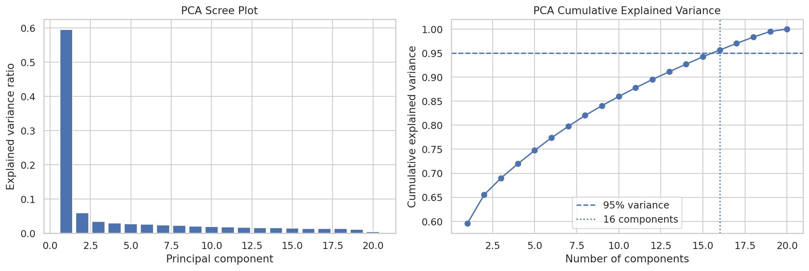
Figure 11. PCA explained variance and cumulative variance.
Feature space | Clusters | Silhouette | Davies-Bouldin | Calinski-Harabasz
Original standardized features | 5 | 0.4489 | 2.3097 | 560.20
PCA space (16 components; >=95% variance) | 5 | 0.4728 | 2.2199 | 637.88

In this experiment, K-Means in the 16-component PCA space produced a higher Silhouette Score and Calinski-Harabasz Score, and a lower Davies-Bouldin Index, than K-Means in the original standardized feature space. This comparison is specific to the current dataset, feature encoding and selected component count.

5.9 PCA, t-SNE and SNE visualizations
PCA provides a linear projection based on directions of maximum variance. The cluster comparison plot uses the first two principal components and colours observations by the labels from each clustering algorithm.
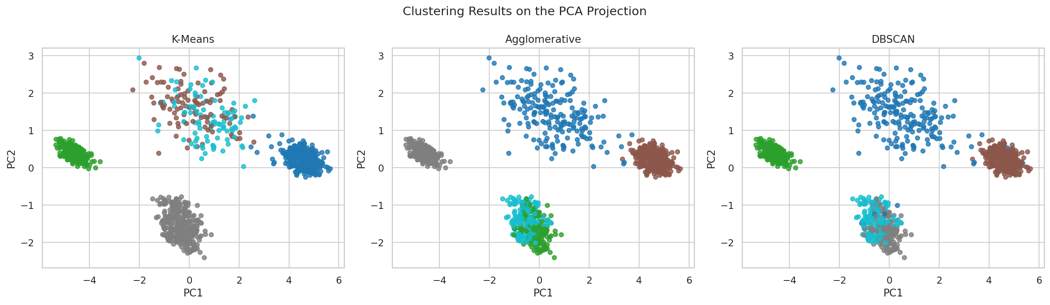
Figure 12. K-Means, Agglomerative and DBSCAN labels on the same PCA projection.
t-SNE was used to create a two-dimensional representation of all 1,100 standardized observations. The recorded settings were two output dimensions, perplexity 30, PCA initialization, automatic learning rate, 1,000 iterations and random_state 42. The t-SNE coordinates were used for visualization, not as the primary space for evaluating clustering quality, because t-SNE can alter global distances and apparent cluster sizes.
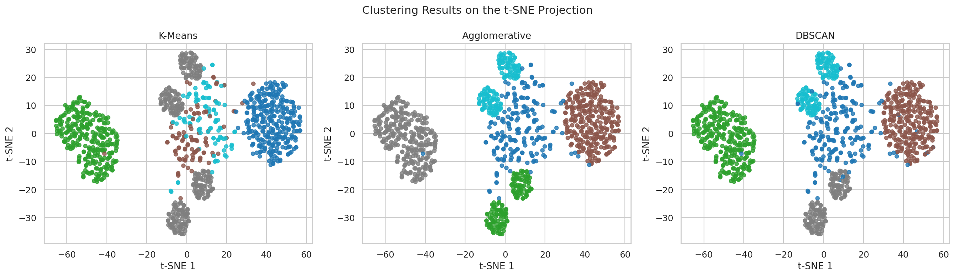
Figure 13. Clustering labels displayed on the t-SNE projection.
Original SNE was implemented using conditional Gaussian probabilities in the original feature space and in the two-dimensional embedding. A deterministic sample of 800 observations was used to keep computation manageable. The optimizer converged after 106 iterations and 111 function evaluations. The final KL objective was 1168.6407, and the gradient norm was 0.0013961. All embedding coordinates were finite.
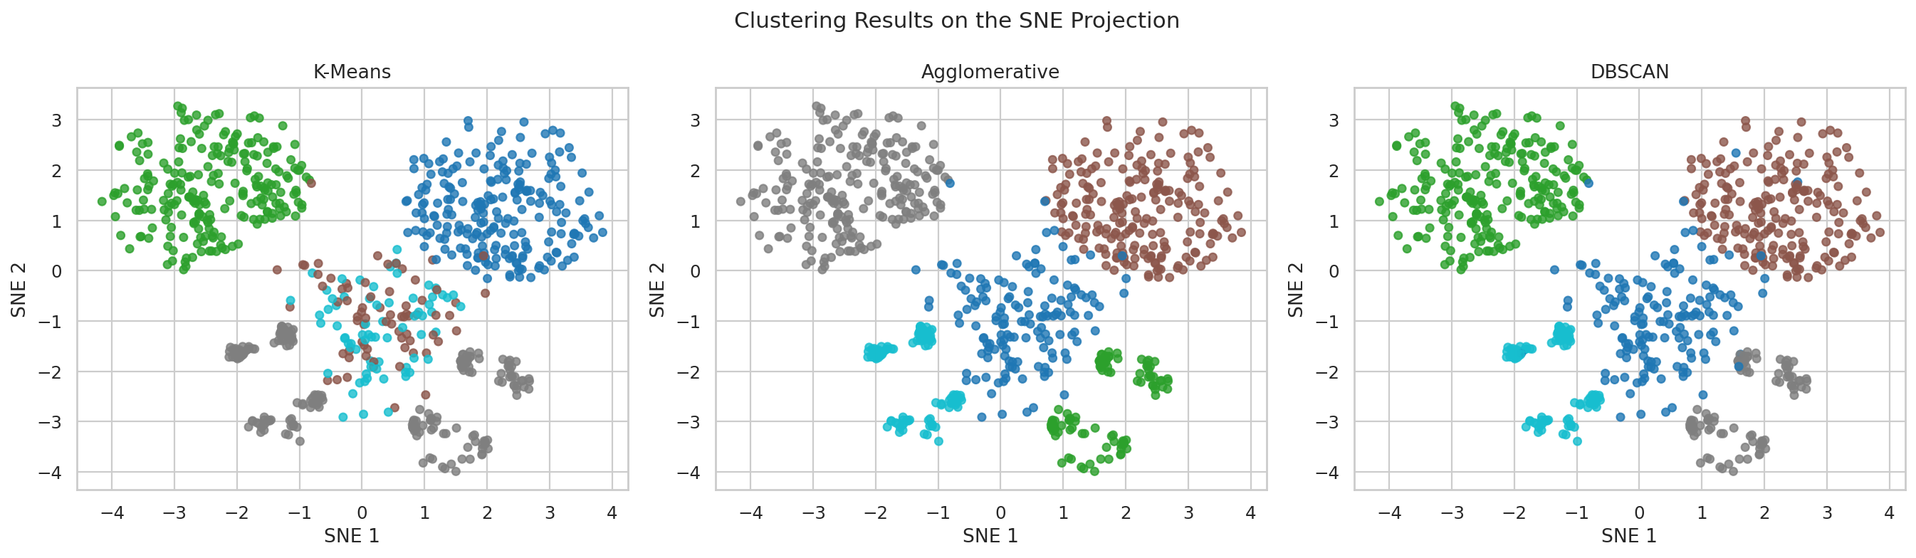
Figure 14. K-Means, Agglomerative and DBSCAN labels on the SNE projection (800-record sample).
The SNE objective value is specific to this implementation and sample. It should not be compared directly with the t-SNE objective. PCA, t-SNE and SNE plots are exploratory visualizations and do not independently establish global cluster separation.

6. Discussion
The experiments show that the student records can be grouped in different ways depending on the clustering method. K-Means produced five groups and assigned every record to a cluster. Its Silhouette Score was higher than that of Agglomerative Clustering among the full-coverage methods. Agglomerative Clustering had a lower Davies-Bouldin Index, showing that the evaluation measures did not identify one method as best on every criterion.
DBSCAN provided a density-based view of the observations. It identified four clusters and left 19% of the records unassigned as noise. The noise cross-tabulations showed that these observations were concentrated in specific groups under K-Means and Agglomerative Clustering. This indicates that some groups formed by partition-based methods did not meet the density requirements used by DBSCAN.
The pairwise ARI results showed strong agreement between Agglomerative Clustering and DBSCAN (0.9819) on the full dataset. Their assignments were identical on the DBSCAN non-noise subset. K-Means had a different partition, although its agreement with Agglomerative Clustering and DBSCAN remained substantial. The post-clustering comparison with stress_level showed the highest ARI for K-Means among the three final methods.
PCA reduced the feature representation to 16 components while retaining at least 95% of the variance. In this run, clustering in the PCA space improved the three reported internal metrics for K-Means. The t-SNE and SNE projections offered additional views of local neighbourhood structure. These plots are useful for exploration, but apparent visual gaps should not be treated as proof of globally separated groups.

Limitations
- The predictor variables are integer-coded scores and ratings. Treating them as ordered numeric distances is a modelling assumption; alternative encodings or feature weighting may change the results.
- The dataset contains 1,100 records. Results may not generalize to other institutions or student populations.
- The survey collection date is not established by the CSV file. The associated research article was published in September 2024.
- DBSCAN internal metrics exclude noise records. Its full-dataset scores are therefore not directly comparable with scores calculated on all observations; the common non-noise subset comparison is reported separately.
- The 2D PCA, t-SNE and SNE embeddings simplify the original data and may distort some distances and relationships. SNE was run on a sample of 800 observations.
- The held-out stress_level column is an existing encoded label, not a clinical outcome. Post-clustering agreement does not establish clinical validity.

7. Conclusions and Recommendations
This project compared K-Means, Agglomerative Hierarchical Clustering and DBSCAN on 20 student stress-related features. The selected K-Means solution contained five clusters and achieved full coverage. Agglomerative Clustering also formed five clusters. DBSCAN identified four density-based clusters and marked 19% of the observations as noise.
The results do not support selecting one algorithm as best on every measure. K-Means had the highest Silhouette and Calinski-Harabasz scores among the full-coverage methods and showed consistent assignments across repeated runs. Agglomerative Clustering had the lower Davies-Bouldin Index. DBSCAN was useful for identifying dense regions and observations that did not meet the selected density threshold. The choice of method depends on whether complete assignment, compactness, or density-based separation is the main objective.
Further work could examine alternative feature encodings, robust scaling, feature weighting and different distance measures. Cluster means and medians should be reviewed alongside the original score definitions before assigning descriptive labels to student groups. Additional validation on data from other student populations would be needed before drawing wider conclusions.

8. Output Files
The notebook saves generated results in the outputs_student_stress folder. The principal outputs are listed below.
Category | Files / contents
Figures | feature_distributions.png; spearman_correlation_heatmap.png; feature_boxplots.png; kmeans_elbow_and_silhouette.png; dbscan_k_distance.png; silhouette_comparison.png; davies_bouldin_comparison.png; calinski_harabasz_comparison.png; cluster_size_comparison.png; dbscan_noise_distribution.png; pairwise_ari_comparison.png; kmeans_cluster_profile_heatmap.png; pca_explained_variance.png; pca_cluster_comparison.png; pca_loadings_heatmap.png; tsne_cluster_comparison.png; original_sne_cluster_comparison.png.
Tables | feature_summary.csv; preprocessing_summary.csv; kmeans_k_selection.csv; dbscan_tuning_results.csv; clustering_model_comparison.csv; cluster_sizes.csv; dbscan_non_noise_subset_comparison.csv; pairwise_ari_comparison.csv; dbscan_noise_distribution.csv; kmeans_cluster_profile_means.csv; kmeans_cluster_profile_medians.csv; posthoc_external_validation.csv; original_vs_pca95_kmeans.csv; pca_loadings_pc1_pc2.csv; tsne_embedding.csv; original_sne_embedding.csv; original_sne_diagnostics.csv; kmeans_stability_pairwise_ari.csv.
Final data | final_cluster_assignments.csv; final_algorithm_comparison.csv; final_cluster_sizes.csv; final_dbscan_non_noise_comparison.csv; final_pairwise_ari_comparison.csv.
Metadata | model_metadata.json, containing dataset dimensions, selected parameters, algorithm names and dimensionality-reduction settings.

Appendix: Notebook workflow
1. Load the dataset and inspect its structure.
2. Perform exploratory data analysis.
3. Separate the held-out label and preprocess the predictor variables.
4. Select K for K-Means and fit the three clustering algorithms.
5. Tune DBSCAN and calculate internal evaluation measures.
6. Compare cluster sizes, pairwise agreement and DBSCAN noise.
7. Run PCA, t-SNE and SNE visualizations.
8. Summarize cluster profiles and perform post-clustering validation.
9. Save tables, figures, assignments and metadata.

